## 

Neutrino Directionality Analysis

Procedure of Reconstructing Incoming Antineutrino Direction from the HFIR 235U Reactor

*Manjinder Oueslati*

Last Revision: December 28th , 2021

**Contents:**

1. **Introduction**
   1. Motivation
   2. PROSPECT Analysis
   3. Antineutrino Analysis
   4. DNP Poster
2. **Data Set**
   1. Data Files
   2. Simulation Files
   3. Code Repository
3. **Neutrino Directionality Results**
   1. IBD Selection Rules
   2. Calculating Distribution Means and Angles
      1. Adjustment to Approach to Code and Distributional Mean Error
   3. Neutrino Directionality Plots
4. **Fiducial Volume Reduction Study**
5. **Left Right Split Study**
6. **Systemic Uncertainties**
   1. Time Drifting in Calibration
   2. Z Position Resolution Study
      1. Cluster Shift by 1-Sigma Gaussian
      2. Prompt Signal Shift by 1-Sigma Gaussian on PhysPulse Files
         1. Applying Fiducial Volume and IBD Distance Cut
         2. Applying Only Fiducial Volume Cut
         3. Applying IBD Distance Cut
         4. Applying No Cut
   3. **Dead Segment Correction Study**
   4. Known Detector Position
7. **Results**
8. **Appendix**

**1 Introduction**

* 1. **Motivation**

Few experiments have conducted a neutrino directionality study. One study, analyzed by Erica Caden from Double Chooz, utilized neutrino directionality to measure the direction of incoming antineutrinos as this measurement could be very useful for locating a supernova or detecting geoneutrinos. PROSPECT expects to exceed that measurement due to our detector segmentation that yields good position resolution with usage of a Lithium-6 scintillator to detect neutrons. Lithium-6 allows for localized neutron capture which gives a more accurate location reading for each event compared to other experiments who utilize Gadolinium. As far as we are aware this is the first time a reactor neutrino experiment has measured neutrino directionality with any precision. In terms of applications, one could determine unknown reactors that have recently sent out signals. Similarly for an astrophysics application, one could determine the direction or location of supernova. Lastly, neutrino directionality is an excellent study for each experiment because it is a good verification of an experiment’s Monte Carlo simulation.

* 1. **PROSPECT Analysis**

PROSPECT, the Precision Reactor Oscillation and SPECTrum Experiment, is a short-baseline reactor antineutrino experiment designed to conclusively address the reactor flux and spectrum anomalies, search for sterile neutrinos, and make the most precise measurement of the antineutrino spectrum from a highly-enriched reactor core. PROSPECT consists of segmented liquid scintillator detectors deployed at a short baseline (7-12 m) from the High Flux Isotope Reactor (HFIR) at Oak Ridge National Laboratory (ORNL) in Tennessee. The 85 MW HFIR reactor is running 41% of the time, and burns highly-enriched uranium fuel, meaning that >99% of neutrinos emitted by the core derive from 235U fissions. The detectors consist of an optically segmented antineutrino target of Lithium-6 doped liquid scintillator surrounded by external passive shielding. Light produced in antineutrino interactions is efficiently propagated using highly specular reflecting segment walls and collected at each segment end with a photomultiplier tube (PMT). Neutron direction is most preserved when scattering off of Hydrogen, which has a large cross-section for neutron scattering at the relevant energy range.

FIG. 1. PROSPECT detector in spatial reference to the HFIR reactor. HFIR core in analysis is treated as a point source rather than as shown below as a cylinder. The 4-ton PROSPECT detector has a segmented design of 154 optically separated segments in a 11x14 array. Each segment is filled with a Li-6 loaded liquid scintillator with high light propagation through double ended photomultiplier tubes that allows for precise event localization and allows for excellent sensitivity to antineutrino oscillation with meter-scale wavelengths. Each segment is approximately 1.17 m in length along Z and 14.5 cm in width along X and Y. The outer rim of the segments that have too much background are classified as fiducial segments and act as an extra layer of shielding. In PROSPECT, background rejection is important to us as our experiment is on the surface of the Earth with little shielding.

In regard to our IBD event classification we require a signal pairing that is dependent on a positron (prompt) signal being paired to a (delayed) neutron signal with spatial, energy, and temporal criteria. Signal categorization is dependent on the delayed neutron’s location because there are fewer neutron events than prompt events. We track single event neutrons and partner them with corresponding prompt events. For our spatial separation requirement, we require the location of the prompt signal to be found in the same (adjacent) segment with a maximum separation of 100 mm (140 mm). Our spatial cut refers to all possible combinations of pairings, however we are mostly concerned with closed delayed pairing which adheres to signals being at maximum, one segment apart. This adjacent measurement excludes contributions from segments that are diagonal. Our IBD energy threshold for prompt energy is between 0.8 and 7.2 Mev, where prompt energy is comparable to antineutrino energy. Our neutron capture time following a prompt signal must be within 1-120 ms and prompt clustering time is between 10-40 ns. The PROSPECT detector has an outer fiducial volume to reduce cosmic background noise. A fiducial cut of +/- 444 mm is applied to the Z position. IBD candidate pairs (correlated or accidental events) are accumulated for reactor on and off periods. Reactor-off backgrounds and accidental (where they represent backward in time pairings, their time window is greater than 1000 microseconds.) miss-pairing are removed to obtain the final candidate distributions. **Include PSD requirement.**

Other possible events are “Singles”, Singles are categorized as either free neutrons or electrons where no pairings are available. Each possible event is simulated individually, backgrounds are not simulated, and accidentals are negligent in comparison. Information regarding IBD variables are found in PROSPECT2x_Analysis/Analysis/PhysPulse/IBDTree.hh

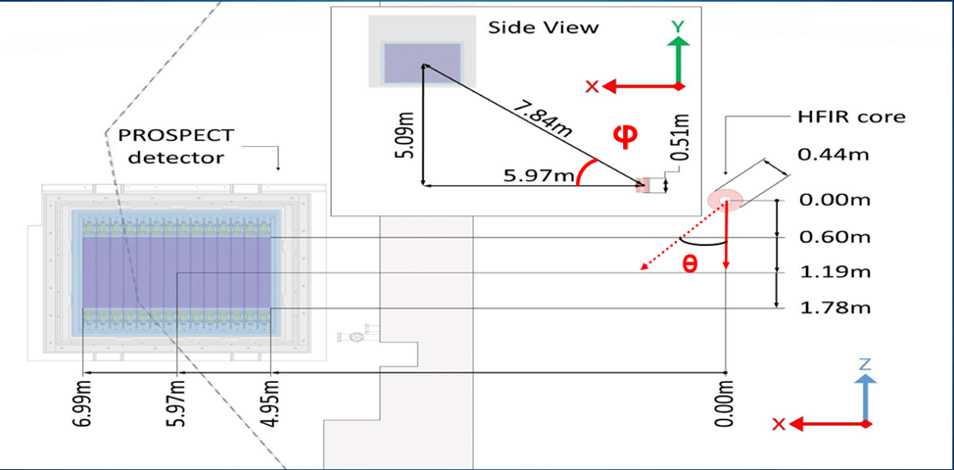

FIG. 2. Figure presented from PROSPECT PRD figure 1. PROSPECT detector dimensions used in our neutrino directionality study. The HFIR core is offset in the Z direction by 1.19m. Our real directionality measurements are taken using the center of our detector with errors in quadrature being represented by the case where the signal reaches the edges of the inner detector volume. θ is the nadir angle (negative zenith) and φ is the azimuthal angle given in the diagram. (φ is between 7.84m and 5.97m & θ is out of the plane due to the -1.19m offset in Z). There are small fluctuations, however overall it is quite stable.

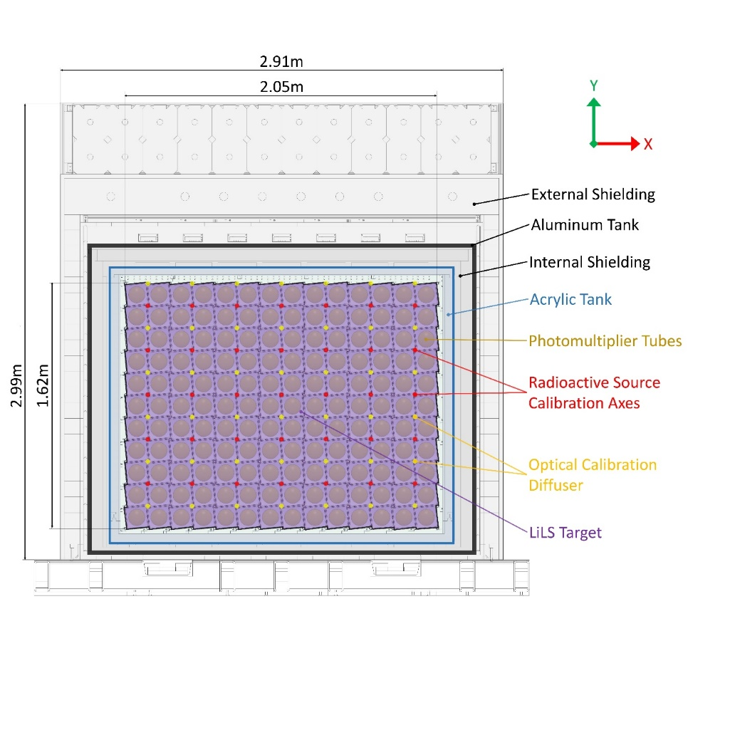

FIG. 3. Side view of PROSPECT detector with each layer of active and fiducial volume

* 1. **Antineutrino Analysis**

When nuclear fission occurs in the reactor core, massive amounts of energy is released, and neutron fission products are produced. This results in multiple nuclear decays until they reach a stable isotope, the most common ones being U-235, U-238, and Pu-239. The antineutrino spectrum from each fission isotope is similar yet distinct because of overlapping product distributions.

Reactors are a pure source of electron antineutrinos (${\overline{ν}}_{e}$), during nuclear fission in the reactor core, a massive amount of energy is released, and fission products are produced. Neutrino energy is comparable to prompt energy.

$${\overline{ν}}_{e}+p →e^{+}+n$$

Per each decay, an electron (beta) particle and an ${\overline{ν}}_{e}$ are produced. IBD tracking follows the location of the reaction products, which undergo annihilation and delayed neutron capture on Li-6. The temporal, energy and spatial coincidences between these events provide an IBD signature in neutrino detectors which allows for pulse shape discrimination (PSD) from background, a method for separating the scintillation signals from particles with different specific ionization, from background.

On average the neutron retains the directional aspect of the antineutrino, which allows for a spatial displacement measurement to reconstruct the direction of the neutrino. A precise measurement of neutrino direction at this energy scale has never been made before.

FIG. 4. Inverse Beta Decay event process of positron annihilation and neutron capture in PROSPECT.

FIG. 6. Emission process of antineutrinos from a nuclear reactor from nuclear fission.

* 1. **DNP Poster**

FIG. 5. Brief Overview of Directional Neutrino Detection with PROSPECT that was presented at DNP Fall 2021 Meeting

1. **Data Set**
   1. **Data Files**

The data Files are taken from PROSPECT-1 PRD data set: March 5th to October 6th, 2018. These files are from the 2019B_GoodRuns_RxStatus.txt. My version of P2x for my analysis is 2020A v.23.1. Veto OUTDIR does not refer to anything in the runs list; it is a fossil from an old analysis that does not affect the data files. Analysis commands can be found in /P2x/bin/.

* 1. **Simulation Files**

Results are compared to a Monte Carlo sample of one million reactor-induced IBD events simulated in PROSPECT. There are 20 Monte Carlo simulation runs that are dependent on a single calibration and have the same configuration file criteria as the data set, these runs are coined “realistic sim”. I also have a second simulation set of runs where the configuration criteria are altered to simulate no dead segments within the detector, hence these runs are coined “perfect sim”. The simulation runs being dependent on a single calibration over the entire data set period is an issue that is addressed in the time drifting calibration study below. All files are at the PhysPulse level and have been inspected by “AnaylzeCalibrated”. The simulation files are also available at the DetPulse level where they have been inspected by “CalcDetectorPulseResponse”. The configuration file used for simulation is AD1_IBD_2020.cfg and has been modified to AD1_Perfect_2020.cfg for the perfect sim analysis; the configuration file is manipulated for multiple studies. Simulation files can be located at:

~/prospect_bundle/MyWork/NeutrinoDirectionality/Simulations/H5Files/.

* 1. **Code Repository**

All Information regarding every version of my code and my various works can be found on my private GitHub repository via the following link:  
<https://github.com/ManjinderOueslati/NeutrinoDirectionality.git>

For all PROSPECT collaborators my work can be found on the Wright server through:

/home/mmo58/prospect_bundle/MyWork/NeutrinoDirectionality/

In both cases, each study has a documented README.txt that explains my thoughts that affected my coding process.

1. **Neutrino Directionality Results**
   1. **IBD Selection Rules**

IBD events are selected through a set of conditions imposed by PROSPECT detailed in the following document:

FIG. 6. IBD event criteria. The number of accidentals in the window is 100.0 and is not specified in this document, this factor is to match the “Reactor On” time window. To adjust for the correlated window, a dead time factor is multiplied to the accidental window per file. The livetime correction to all reactor off files is applied after the summation over all files to account for the total reactor times. The atmospheric scale is approximately 1.0.

* 1. **Calculating Distribution Means and Angles**

The distribution means are calculated independently of one another and are derived in a similar fashion to recording the final IBD spectrum:

$$μ= \sum_{files}{\left({\left(Correlated-\left(Accidental*\frac{x^{files}}{acc_{window}}\right)\right)}^{files ϵ RxOn}-\left(\left(\frac{livetimeOn}{livetimeOff}\right)*\left(atm_{scale}\right){\left(Correlated-\left(Accidental*\frac{x^{files}}{acc_{window}}\right)\right)}^{files ϵ RxOff}\right)\right)} \left(Eqn. 1\right)$$

$x^{f}$ refers to a deadtime fraction and $acc_{window}$ refers to the number of accidental windows applied to all accidental events to correct to the correlated window. $RxOn$ and $RxOff$ refers to the HFIR reactor status.

Originally described in figure 6, histograms were used to calculate the distribution means. Which is still a plausible and correct method, however I utilize arrays for algebraic manipulation when necessary. Histograms are eventually utilized, and their bin contents are set using these arrays where I name them “LTF Arrays” (Live Time Fraction Arrays). Their bin errors are set by “Err Arrays” (Error Arrays) which record the difference in position between the prompt and delayed event (diff index).

Position reconstruction drives directional reconstruction. Assume everything in the XY plane is in center of segment as events are detected by segment and the IBD distance cut limits variation in the XY plane. In the Z plane, there is 50mm of position resolution applied to our IBD analysis. Reconstructing the incoming neutrino’s direction requires constructing a vector, pointing from the positron’s reconstructed position to the neutron’s reconstructed position. Hence the Z dimension is limited by the same constraints applied to the X and Y dimensions which is shown in the distribution plots.

Each type of event is recorded into these arrays and indexed by this “diff index” independently for each dimension in X,Y, and Z. The “diff index” depends on the location of the prompt event in the reference frame of the delayed event. $$p_{i}=p_{i}^{delayed}-p_{i}^{prompt} \left(Eqn. 2\right)$$

This allows for us to observe the neutrino direction to point away from the detector and towards the reactor. In regard to the X and Y dimension, this “diff index” signal can only be found in the center of the segment or in adjacent segments in exactly one segment spacing apart (145.7mm). Due to this limitation, the histogram binning is filled with three discrete values in the X-Y plane. We do not impose the Y dimension onto the contents in the X histogram because we lack information regarding diagonal segments. Each distribution mean and associated sigma error value is pulled from the given final dimension histogram through ROOT’s functions of “GetMean” and “GetStdDev”:

$$p_{z} = hDataZDiff→GetMean(1);$$

$$p_{z} = hDataZDiff→ GetStdDev(1);$$

The reduction in “IBD Count” allows for a measurement of effective counts:

$$Effective Counts=\frac{IBD Counts^{2}}{Error in Counts^{2}} \left(Eqn. 3\right)$$

Similar to a standard Poisson distribution where:

$$N_{eff}\left(Counts\right)=\frac{N^{2}}{\sqrt[2]{N^{2}} } (Eqn. 4)$$

Since we are doing a background subtraction, our error in our IBD count is additive rather than subtractive, so the error is higher than just the square root of “N”. The “Effective IBD Count” is used as your total N value when performing the error analysis of your theta and phi values.

In the Double Chooz neutrino experiment the calculations for θ and φ are derived by a gaussian distribution of the components with width P, because of their cylindrical geometry that allows for uniform width in all directions $(p = (p_{X},p_{Y},p_{Z})).$ Initially PROSPECT assumes p is approximately equal in all directions, with the width in P representing the largest error variation in data for a conservative error analysis.

Equations are also given by Double Chooz, and errors are measured using error propagation formulas:

$$δf=\sqrt{{\left(δx\right)}^{2}+{\left(δy\right)}^{2}+{\left(δz\right)}^{2}} (Eqn. 5)$$

$$p_{i}=μ_{i} (mean) \& uncertainty Δ{\overline{p}}_{i}≃\frac{σ_{i}}{\sqrt{N_{i} }} \sim \frac{P}{ \sqrt{N}} (Double Chooz)$$

$$For comparing different sims: Δμ_{i}$$

$$tan ϕ =\frac{{\overline{p}}_{y}}{{\overline{p}}_{x}} (Eqn. 6)$$

$$∂_{y} \left(\tan{ϕ}\right)=\frac{1}{{\overline{p}}_{x}}→Δ_{y} \left(\tan{ϕ}\right)=\frac{Δ{\overline{p}}_{y}}{{\overline{p}}_{x}}$$

$$∂_{x}\left(\tan{ϕ}\right)=\frac{{\overline{p}}_{y}}{{\overline{p}}_{x}^{2} }→Δ_{x} \left(\tan{ϕ}\right)=-\frac{\left(Δ{\overline{p}}_{x} ∙ {\overline{p}}_{y}\right)}{{\overline{p}}_{x}^{2} }$$

$$Δ\left(tan ϕ\right)= \sqrt{{\left(\frac{Δ{\overline{p}}_{x}*{\overline{p}}_{y}}{{\overline{p}}_{x}^{2}}\right)}^{2}+{\left(\frac{Δ{\overline{p}}_{y}}{{\overline{p}}_{x}}\right)}^{2}}=\sqrt{{\left(\frac{P*{\overline{p}}_{y}}{{ \overline{p}}_{x}^{2}\sqrt{N_{eff}}}\right)}^{2}+{\left(\frac{P}{{\overline{p}}_{x }\sqrt{N_{eff}}}\right)}^{2}}\left(Eqn. 7\right)$$

$$\tan{θ}=\frac{{\overline{p}}_{z}}{\sqrt{{\overline{p}}_{x}^{2}+{\overline{p}}_{y}^{2}}}=\frac{{\overline{p}}_{z}}{\left|{\overline{p}}_{r}\right|} , where {\overline{p}}_{r}=\sqrt{{\overline{p}}_{x}^{2}+{\overline{p}}_{y}^{2}} (Eqn. 8)$$

$$∂_{z} \left(\tan{θ}\right)=\frac{1}{{\overline{p}}_{r}^{ }} →Δ_{z} \left(\tan{θ}\right)=\frac{Δ{\overline{p}}_{z}}{{\overline{p}}_{r}^{ }}$$

$$∂_{j=x,y}\left(\tan{θ}\right)=-\frac{{\overline{p}}_{z}{\overline{p}}_{j}}{{\left({\overline{p}}_{r}^{ }\right)}^{3}} →Δ_{j}\left(\tan{θ}\right)=-\frac{{\overline{p}}_{z}{\overline{p}}_{j}}{{\left({\overline{p}}_{r}^{ }\right)}^{3}}∙Δ{\overline{p}}_{j}$$

$$Δ\left(tan θ\right)= \sqrt{{\left(\frac{1}{\sqrt{{\overline{p}}_{x}^{2}+{\overline{p}}_{y}^{2}}}\right)}^{2}\left[{\left(Δ{\overline{p}}_{z}\right)}^{2}+{\left(\frac{Δ{\overline{p}}_{y}*{\overline{p}}_{y}{\overline{p}}_{z}}{{\overline{p}}_{x}^{2}+{\overline{p}}_{y}^{2}}\right)}^{2}+{\left(\frac{Δ{\overline{p}}_{x}*{\overline{p}}_{x}{\overline{p}}_{z}}{{\overline{p}}_{x}^{2}+{\overline{p}}_{y}^{2}}\right)}^{2}\right]}= \\ \sqrt{{\left(\frac{P}{\sqrt{N_{eff}}* \sqrt{{\overline{p}}_{x}^{2}+{\overline{p}}_{y}^{2}}}\right)}^{2}\left[1+{\left(\frac{{\overline{p}}_{y}{\overline{p}}_{z}}{{\overline{p}}_{x}^{2}+{\overline{p}}_{y}^{2}}\right)}^{2}+{\left(\frac{{\overline{p}}_{x}{\overline{p}}_{z}}{{\overline{p}}_{x}^{2}+{\overline{p}}_{y}^{2}}\right)}^{2}\right]}\left(Eqn. 9\right)$$

**2.3.1 Adjustment to Coding Approach and Distributional Mean Error**

In our adjustment we treat the X and Y histograms as distinct segmented lists where the center segment only contains signals from active segments where the prompt signal is only found in the same segment as the delayed neutron. This allows for a precise error analysis that removes any conservative count of a gaussian width and an accurate count of IBD events in each dimension.

Equation 7 and 9 respectively become:

$$Δ\left(tanϕ\right)= \sqrt{{\left(\frac{Δ{\overline{p}}_{x}*{\overline{p}}_{y}}{{\overline{p}}_{x}^{2}}\right)}^{2}+{\left(\frac{Δ{\overline{p}}_{y}}{{\overline{p}}_{x}}\right)}^{2}}=\sqrt{{\left(\frac{σ_{x}*{\overline{p}}_{y}}{{ \overline{p}}_{x}^{2}\sqrt{N_{x}}}\right)}^{2}+{\left(\frac{σ_{y}}{{\overline{p}}_{x }\sqrt{N_{y}}}\right)}^{2}} \left(Eqn. 10\right)$$

$$Δ\left(tan θ\right)= \sqrt{{\left(\frac{1}{\sqrt{{\overline{p}}_{x}^{2}+{\overline{p}}_{y}^{2}}}\right)}^{2}\left[{\left(Δ{\overline{p}}_{z}\right)}^{2}+{\left(\frac{Δ{\overline{p}}_{y}*{\overline{p}}_{y}{\overline{p}}_{z}}{{\overline{p}}_{x}^{2}+{\overline{p}}_{y}^{2}}\right)}^{2}+{\left(\frac{Δ{\overline{p}}_{x}*{\overline{p}}_{x}{\overline{p}}_{z}}{{\overline{p}}_{x}^{2}+{\overline{p}}_{y}^{2}}\right)}^{2}\right]}=\sqrt{{\left(\frac{1}{\sqrt{{\overline{p}}_{x}^{2}+{\overline{p}}_{y}^{2}}}\right)}^{2}\left[{\left(\frac{σ_{z}}{\sqrt{N_{z}}}\right)}^{2}+{{\left(\frac{σ_{y}}{\sqrt{N_{y}}}\right)}^{2}*\left(\frac{{\overline{p}}_{y}{\overline{p}}_{z}}{{\overline{p}}_{x}^{2}+{\overline{p}}_{y}^{2}}\right)}^{2}+{{\left(\frac{σ_{x}}{\sqrt{N_{x}}}\right)}^{2}*\left(\frac{{\overline{p}}_{x}{\overline{p}}_{z}}{{\overline{p}}_{x}^{2}+{\overline{p}}_{y}^{2}}\right)}^{2}\right]} (Eqn. 11)$$

In our case each dimensional IBD count will be estimated ( $N_{x}, N_{y},$ $N_{z})$ to be our effective IBD count ($N_{eff}$) to simplify our error analysis. $σ_{x}$ and $σ_{y}$ are explicitly calculated below, while $σ_{z}$ is pulled from a histogram of the data using the ROOT method because it is unchanged by the X-Y planar analysis:

The initial method to obtain the uncertainty equations used for the Dead Segment Correction study:

$Δx_{-}=\sqrt{N_{0}*\frac{N_{-}}{N_{0-}}}$ $Δx_{+}=\sqrt{N_{0}*\frac{N_{+}}{N_{0+}}}$ $Δx_{0}=\sqrt{N_{0}} (Eqn. 12)$

After adjusting for a detailed uncertainty analysis:

$$Δx_{-}=\sqrt{\left(N_{-}{\left(\frac{N_{0}}{N_{0-}}\right)}^{2}+N_{0-}{\left(\frac{\left(N_{-}N_{0-}-N_{0}N_{-}\right)}{N_{0-}^{2}}\right)}^{2} +N_{0-}^{C}{\left(\frac{N_{-}}{N_{0-}}\right)}^{2} \right)}$$

$$Δx_{+}=\sqrt{\left(N_{+}{\left(\frac{N_{0}}{N_{0+}}\right)}^{2}+N_{0+}{\left(\frac{\left(N_{+}N_{0+}-N_{0}N_{+}\right)}{N_{0+}^{2}}\right)}^{2} +N_{0+}^{C}{\left(\frac{N_{+}}{N_{0+}}\right)}^{2} \right)}$$

$$Δx_{0}=\sqrt{N_{0}} (Eqn. 13)$$

In both cases $σ_{x} and σ_{y}$ are given below:

$$σ_{x}=\frac{\sqrt{Δx_{-}^{2}{\left(D+{\overline{p}}_{x}\right)}^{2}+Δx_{+}^{2}{\left(D-{\overline{p}}_{x}\right)}^{2}+Δx_{0}^{2}{\left({\overline{p}}_{x}\right)}^{2}}}{\sqrt{N_{eff}}} \left(Eqn. 13\right)$$

$$σ_{y}=\frac{\sqrt{Δy_{-}^{2}{\left(D+{\overline{p}}_{y}\right)}^{2}+Δy_{+}^{2}{\left(D-{\overline{p}}_{y}\right)}^{2}+Δy_{0}^{2}{\left({\overline{p}}_{y}\right)}^{2}}}{\sqrt{N_{eff}}} (Eqn. 14)$$

Dead Segment Correction Study

Original Delta Values:

Detailed Delta Values:

**Editing Here**

* 1. **Neutrino Directionality Plots**

------------------------------------------------------------------------------------------------------------------

Christian’s Work

Christian’s version of P2x is 2019C

* Code:
* Change of Analysis Method: (From histograms to vectors):   
  Initially, what I was doing is using histograms and binning the separation in 1 mm increments (which was rounding everything to the nearest mm). Those histograms included just the counts from the IBDs, so I also made arrays to store those x time factors. When I realized that was biasing the results a bit, I switched to using those vectors that stored things in much higher precision.
* Reactor Off (RxOff) & Reactor On (RxOn) are represented by “0” and “1” respectively in PROSPECT.
* Correlated IBDs are IBDs where the neutron capture occurs between 1 and 120 us after the prompt signal. Accidentals are IBDs with neutrons capturing over 1 ms after the prompt. We want the Correlated IBDs since they are actually physical, but accidentals are weird, so that is why we subtract them off.
* AccOnX, CorOffX, etc are the vectors that save the dead time factor x which you need when doing the dead time correction. When I use histograms, I just fill them with the x factor, which is constant over each file you read in. aveCorOff, etc. are the variables I use to calculate the average values. If you think about it in histogram terms, it is the x value times the y value, both of which you need to know where the average is located.
* In the error calculation, assuming the accidental window is divided by 10,000 properly similar to the correlated time window (Specified in PRD).
* Studies performed:
  + Left-Right Study: Splits the detector in half through the XY plane (Incorrect view of detector dimensions).
  + Baseline Study: Analyzed the prompt and delayed signal through various meter baselines in the detector. Pictured below.
  + RxOff/RxOn Study
  + Capture Time Study
  + Dead Segment Study
  + Energy Study: Looked at various limits on the maximum prompt energy given an IBD candidate.

My Addition to this Project: (Manjinder Oueslati)

* Code and Studies:
* Original Study
  + Data: NeutrinoDirectionality.cc

Realistic Simulation: DirectionalitySim.cc

Perfect Simulation: DirectionalityPer.cc

Initially, I used a different calibration file than Christian, but I have updated my analysis for this. My MC simulation files are calibrated under the same version of P2x as the real data. My mean values of position distributions are more accurate when compared to the values the equations yield. When creating the simulated runs Christian used a singular calibration file, rather than each run having an independent calibration through PROSPECT’s data taking period. To address this issue, I choose two additional different calibration files to recreate the simulated runs and compare to analyze any time drifting effect between the calibration.

* + Fiducial Volume Study
    - FiducialCut.cc, SimFiducialCut.cc, PerFiducialCut.cc
    - Sanity check study to analyze the outer fiducial regions and to visualize how IBD candidates are lost near the fiducial edge of the detector by AnalyzeCalibrated. Essentially, the fiducial Z cut applied in the IBD configuration file is reduced from +/- 444mm to 394mm (1-sigma) and then 344mm (2-sigma).
  + Time Drifting (Simulation)
    - Choose three various calibration files across PROSPECT’s data taking period and compare their effects. Overall not significant change, so we opt to use the middle (June) calibration file as an average for future simulations. This was done to prove our single calibration choice is not affecting our analysis.
    - Dealing with neutrons that go into dead segments or out of the detector (Edge effects). And dealing with systematic uncertainties such as position resolution. How much our results can drift from some effect and thus the uncertainty of that effect on the measurement.
    - Files:
      * March 18th (s001_f00260_ts1522250629):
      * June 18th (s001_f00140_ts1529347095):
      * September 18th (s001_f00355_ts1537288053):
  + Left Right Study
    - My Left/Right Study will be conducted inside the segment and in the Z plane as Z (the longitudinal direction of the segments) is normal to the reactor direction.
    - We use segment clusters in X & Y for baselines because they are discrete distances from the reactor. Hence the baseline study.
    - I will apply a normal fiducial boundary then separately do the same while restricting the fiducial volume by 5.0cm on either side so there are no signals that spill outside of the regions the detector or onto the other side while also analyzing how much the uncertainty in the fiducial volume plays a role in this measurement. We require the full IBD to be detected on one side (both prompt and delayed signals)
    - Left: -444mm to 0mm & Tight Left: -394mm to -50mm
    - Center: -222mm to 222mm & Tight Center: -172mm to 172mm
    - Right: 0mm to 444mm & Tight Right: 50mm to 394mm
  + Systematic Uncertainty in Z Reconstructed Position Resolution
    - ***In MC we are shifting each pulse to see if position reconstruction is based on pulse. z-position is smeared.***
    - I think Russell is correct about the 2 z-cuts being the driving force behind this displacement in theta. Phi looks like it is being driven by the holes in the detector.
    - 1-D systematic uncertainty on the directional parameter angles due to the 5-cm z-positional reconstruction uncertainty, calculate the %difference between the shift in the central value of the Gaussian-adjusted MC to the central value of the nominal results, for both parameters:

%Diff Theta = 100*(-1 + theta_shift/theta_0)

%Diff Phi = 100*(-1 + phi_shift/phi_0)

* + - A random gaussian shift is applied at the Physpulse level where the z coordinate is the reconstructed MC Z position and is not clustered yet for prompt and delayed signals. A random gaussian shift is also applied post cluster creation of prompt and delayed; we alter the .cfg file limits via AnalyzeCalibrated accordingly:
      * No difference b/w FV & IBD Distance cut applied via AnalyzeCalibrated or at the cluster level by me. (Shifting at cluster level before cuts varies the simulated ibd count, however they average out back to the constant value)
      * Original (Real) .cfg limits (IBD Distance (140mm,100mm) (adj cell, same cell) and +/- 444mm in the Z Fiducial volume)
      * No (Extended) .cfg limits (IBD Distance (1200mm,1200mm) (adj cell, same cell) and +/- 600mm in the Z Fiducial volume)

Too many plots for these 8 cases:

Realistic Sim: Perfect Sim:  
SimOrigLimitsCluster PerOrigLimitsCluster  
SimOrigLimitsPulse PerOrigLimitsPulse  
SimNoLimitsCluster PerNoLimitsCluster

SimNoLimitsPulse PerNoLimitsPulse

* + - Analyzed No cuts, FV volume cut, IBD Distance cut, and both cuts independently in all cases to determine each cut’s effects. (20 cases). Z plots and Angular plots below with gaussian shift applied to both prompt and delayed in both cases.

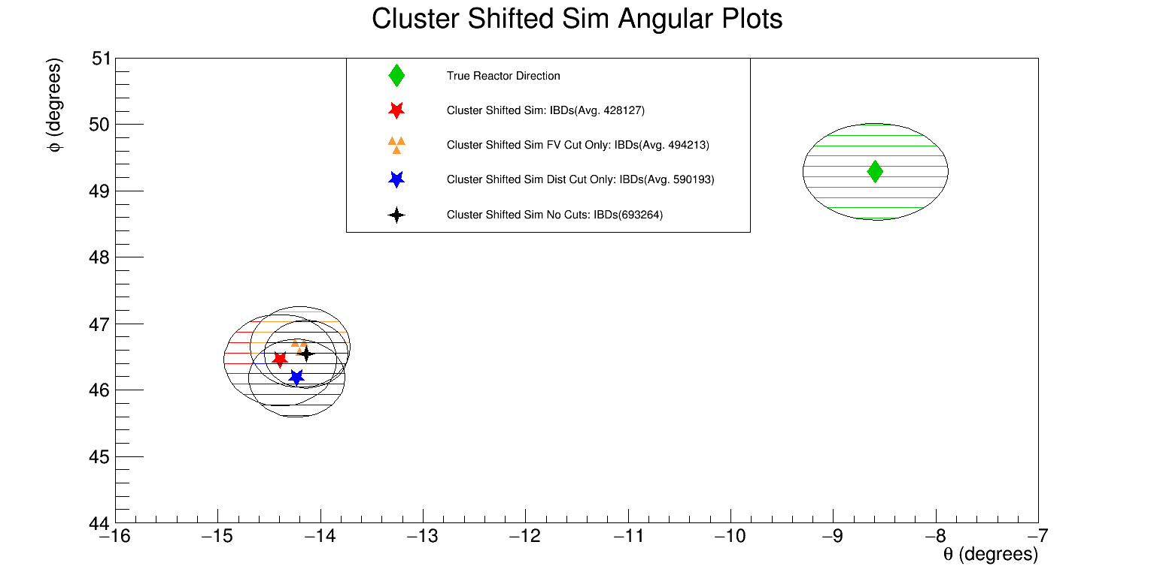

* + - **Analyzed Sim_zsmear in the .cfg file. It does not actually do anything to my simulations: (ZSmear). Set to 50mm because that is the actual uncertainty in Z.**
      * Set Sim_zsmear = 50mm (DirectionalityPer, sim_zsmear = 40mm)
      * Set Sim_zsmear = 0mm
      * Set Sim_zsmear = 0 with a pulse shift applied at physpulse level = PerOrigLimitsPulse Chart, histogram

        Description automatically generated
    - **Prompt Only Check** – Only apply Gaussian shift to prompt signal and plot the prompt Z position for cluster level and physpulse level shift:  
      Chart

      Description automatically generated with low confidenceChart

      Description automatically generated with low confidence
    - Comparing Event Numbers b/w

9. Appendix:

Scientific papers used as references are provided by Erica Caden and Double Chooz for their previous work on Neutrino Directionality in their experiment. I have also provided PROSPECT papers that were utilized to understand their IBD calculations and detector geometry.All papers can be found within the main branch of my private Neutrino Directionality Repository. Links are provided below if the GitHub repository if unavailable.

PROPERLY LIST REFERENCES

   